1. What are the softwares that help to run Java programs?
The main software required for developing and running Java programs are JDK, JRE and JVM. An IDE such as Eclipse or NetBeans can also be used to write, compile and run Java programs easily.
JDK (Java Development Kit): Used for developing Java programs.
JRE (Java Runtime Environment): Provides the environment to run Java programs.
JVM (Java Virtual Machine): Executes Java bytecode.
IDE: Helps in writing, debugging and running programs.

2. What is JDK and JRE?
JDK (Java Development Kit):
JDK is a software package used to develop and run Java programs. It contains tools such as the Java compiler and JRE.
JRE (Java Runtime Environment):
JRE provides the environment required to run Java programs. It contains the JVM and required Java libraries.
Difference:
JDK is used for development as well as execution, whereas JRE is mainly used for execution of Java programs.

3. What is Eclipse IDE?
Eclipse IDE is an Integrated Development Environment used mainly for developing Java applications. It provides facilities for writing, compiling, running and debugging Java programs. It also helps in managing projects, classes and files easily.

4. How to run the Java program in Eclipse/NetBeans IDE?
The following steps are used to run a Java program:
1. Install the JDK on the computer.
2. Open Eclipse/NetBeans IDE.
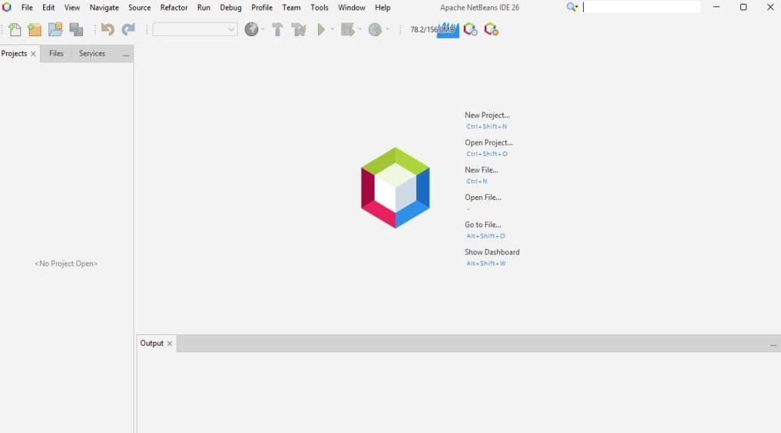
3. Create a new Java project.
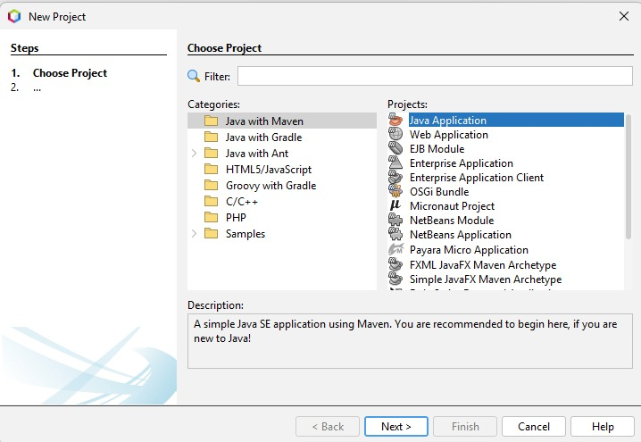
4. Create a Java class inside the project.
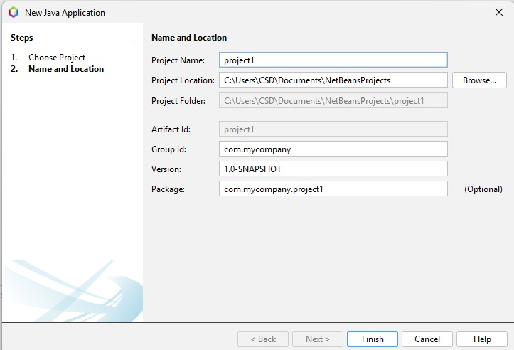
5. Write the Java program in the class.
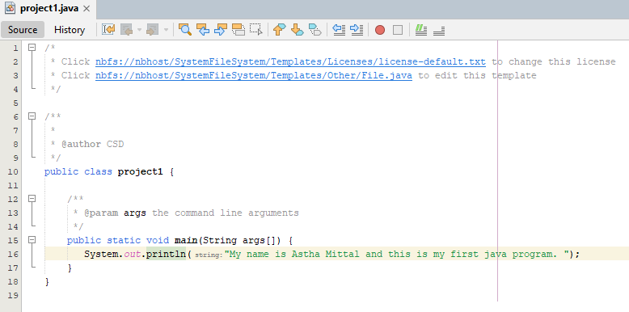

6. Save the program.
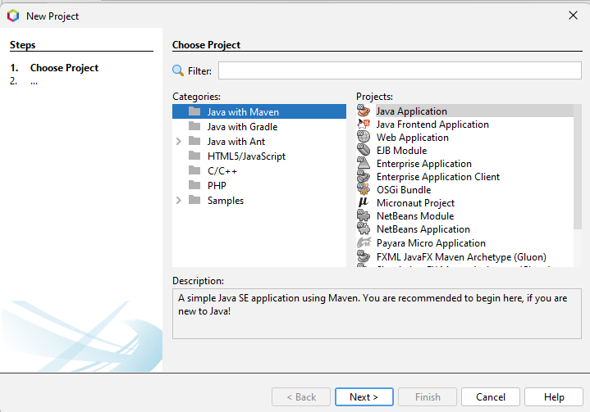
7. Click on the Run option.
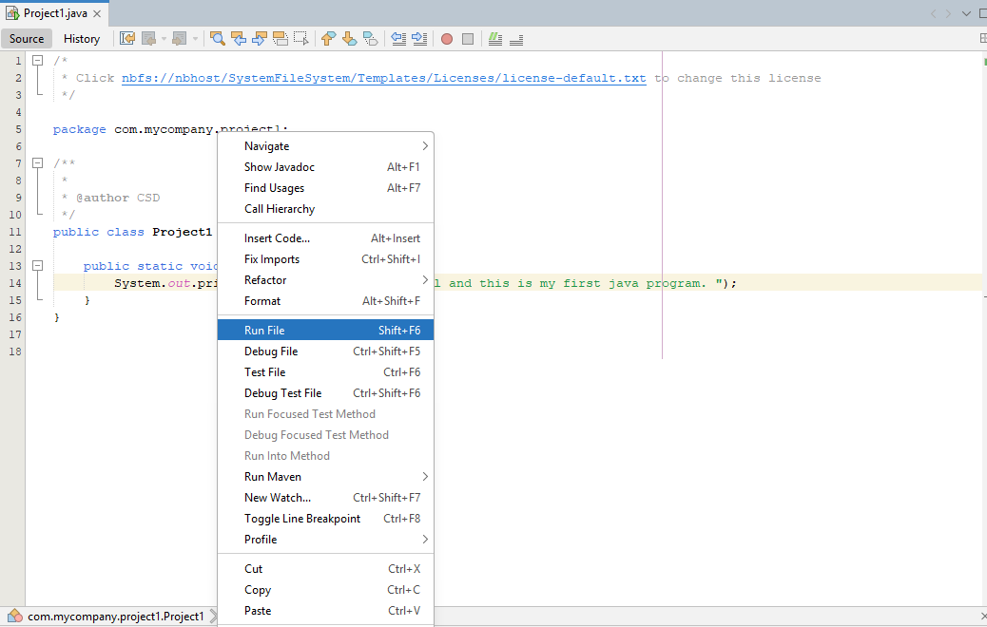
8. The output will be displayed in the Console/Output window.
